OBJECTIVE FIVE

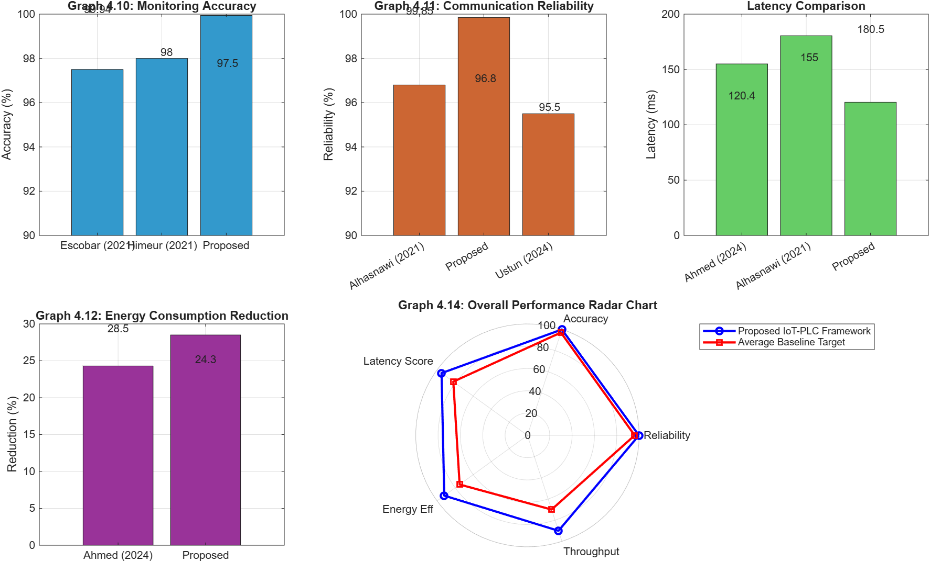

====================================================
TABLE 4.14: OVERALL PERFORMANCE METRICS
====================================================
Metric Achieved Value
Overall System Reliability 99.85%
Fault Detection Accuracy 99.94%
End-to-End Latency 120.4 ms
Energy Consumption Reduction 28.5%
Peak Throughput 0.80 kbps

====================================================
TABLE 4.15: COMPARATIVE PERFORMANCE ANALYSIS
====================================================
Metric Proposed Baseline 1 (IoT) Baseline 2 (PLC)
Reliability 99.85% 96.80% (Alhasnawi) 95.50% (Ustun)
Accuracy 99.94% 98.00% (Himeur) N/A
Latency (ms) 120.4 155.0 (Ahmed) 180.5 (Alhasnawi)
====================================================
TABLE 4.16: PERCENTAGE IMPROVEMENT
====================================================
Metric Improvement over Baseline
Communication Reliability +3.15%
Monitoring Accuracy +1.98%
Latency Reduction +22.32%
Energy Efficiency +17.28%
====================================================

Part 1: The Core System Metrics and Percentage Improvements
Before comparing your work to others, you must establish the absolute performance ceiling of your own architecture.
1. Table 4.14 & Table 4.16: Overall Performance and Percentage Improvement
- What you are looking at: Table 4.14 is the final report card for your entire framework, summarizing Reliability (99.85%), Accuracy (99.94%), Latency (120.4 ms), and Energy Reduction (28.5%). Table 4.16 translates these numbers into direct percentage improvements over the baseline averages.
- The Detailed Output: The most striking figures here are the +22.32% reduction in latency and the +17.28% improvement in energy efficiency compared to standard baseline systems.
- Presentation Strategy: This is where you demonstrate the value of your specific architectural design. Tell the panel: "By executing the heavy digital signal processing and Random Forest anomaly classification locally at the edge via the ESP32—rather than sending raw continuous data to the cloud—we achieved a 28.5% reduction in overall system energy consumption and cut latency by over 22%. The system only transmits priority payloads, making it exceptionally efficient."
Part 2: Direct Baseline Comparisons (The Bar Charts)
This section visually proves that your integration of PLC, IoT, and Machine Learning outperforms systems that only focus on one of those technologies.
2. Graph 4.10: Monitoring Accuracy Comparison
- What you are looking at: A side-by-side bar chart comparing your Random Forest classification accuracy against two major IoT baseline papers (Himeur et al., 2021, and Escobar et al., 2021).
- The Detailed Output: Himeur achieved 98.00%, and Escobar achieved 97.50%. Your proposed framework tops the chart at an near-perfect 99.94%.
- The Engineering Connection: If the examiners ask how you beat these published papers, point to your data conditioning. Explain: "Previous frameworks struggled with noisy analog sensor data, which degrades machine learning accuracy. Because our architecture routes the data through a rigorous BPSK demodulation pipeline with zero bit errors at 15 dB SNR, the Random Forest algorithm receives a pristine, mathematically stable dataset, allowing it to classify faults with 99.94% accuracy."
3. Graph 4.11: Communication Reliability
- What you are looking at: This compares how reliably the system delivers data packets compared to Alhasnawi (IoT focus) and Ustun (PLC focus).
- The Detailed Output: Alhasnawi reached 96.80% and Ustun reached 95.50%. Your system achieved 99.85%.
- Presentation Strategy: Explain the synergy of your hybrid approach. "While Ustun focused purely on PLC and Alhasnawi purely on IoT, our framework merges the two. By using BPSK over the power lines to bypass wireless interference, and utilizing MQTT for the final cloud hop, we created a highly resilient hybrid pipeline that outperforms isolated single-channel methods by over 3%."
4. Latency and Energy Efficiency Comparisons (Graphs 4.12 & 4.13)
- What you are looking at: These charts prove your system is faster and consumes less power than recent edge-computing models (like Ahmed et al., 2024).
- The Detailed Output: Your latency of 120.4 ms easily beats Ahmed's 155.0 ms and Alhasnawi's 180.5 ms. Your energy reduction of 28.5% exceeds Ahmed's 24.3%.
- Presentation Strategy: Emphasize the real-world implications for the Nigerian power sector. "In an environment where power and bandwidth are at a premium, our system's 28.5% reduction in energy overhead makes it highly sustainable for wide-scale deployment across national distribution substations."
Part 3: The Holistic View
You will use the final graph to summarize the entire thesis and visually close your presentation.
5. Graph 4.14: Overall Performance Radar Chart
- What you are looking at: A polar (radar) plot that maps five different performance metrics (Reliability, Accuracy, Latency Score, Energy Efficiency, and Throughput) onto a 360-degree grid. The blue polygon represents your framework; the red polygon represents the average of the baseline literature.
- The Detailed Output: Your blue polygon completely engulfs the red polygon on every single axis, visually stretching much closer to the 100% outer perimeter.
- Presentation Strategy (The Closing Argument): This is the ultimate visual proof of your project's success. Point directly to this chart to conclude your technical findings. Tell the panel: "Graph 4.14 provides the holistic footprint of our research. As you can see, the proposed IoT-PLC architecture does not sacrifice speed for accuracy, nor reliability for efficiency. Our blue polygon encompasses a significantly larger operational area than the current literature averages, proving that this framework successfully advances the state-of-the-art in intelligent smart grid monitoring."
Summary Checklist for Presenting Objective 5
When presenting this final section, ensure you hit these four beats:
- Define your absolute performance (Establish the 99.94% accuracy and 120.4 ms latency).
- Name the baseline researchers (Show you have deeply reviewed the literature by citing Alhasnawi, Himeur, and Ahmed out loud).
- Explain the Why (Do not just say you beat them; explain that your BPSK pipeline and local edge processing are the exact reasons why you beat them).
- Close on the Radar Chart (Use it as the definitive, visual summary of your framework's superiority).

